NAME: U.KAVITHA
DEPARTMENT: COMPUTER SCIENCE
CLASS: III – BSc c.s.,
PROJECT TITLE: EVENT INVENTATION

EVENT INVENTATION

Introduction:
The Event Invitation Project focuses on designing a clear, attractive, and well-structured invitation that effectively communicates essential event details to the intended audience.
This project aims to develop an invitation that is visually appealing, easy to understand, and suitable for the event’s theme and audience. Through this project, we explore principles of design, communication, and layout to produce a professional and inviting document that encourages recipients to participate. The final invitation will demonstrate thoughtful planning, creativity, and effective use of written and visual elements.

Overview:
The Event Invitation Project is designed to create a well-structured and visually appealing invitation that effectively communicates all essential details about an event. This project highlights the importance of clear communication, creative design, and proper formatting in producing an invitation that captures attention and encourages attendance.In this project, the focus is on understanding the purpose of an invitation, selecting appropriate wording, and applying suitable layout and design elements.

Frontend (Client Side):
The frontend is what the user sees and interacts with.
For an Event Invitation System, the frontend handles the visual layout, input forms, and display of event information.

Frontend Components:

a. Event Invitation Form
- Event Name
- Date & Time
- Venue
- Description
- RSVP details

b. User Interface Pages
- Home Page
- Create Invitation Page
- View Invitation Page
- Invitation Preview Page
- Send/Share Invitation Page

c. Technologies Used (Examples)
- HTML → structure of the pages
- CSS → styling of the invitation layout
- JavaScript → form validation and user interactions
- Bootstrap/Tailwind (optional) → responsive design

Frontend Responsibilities
- Collect user input
- Display event invitations
- Validate required fields
- Provide a clean, attractive UI
- Show confirmation messages

Backend (Server Side):
The backend is responsible for storing information, processing data, and managing user requests.
It runs behind the scenes and connects the frontend to the database.

Backend Components:

a. Server-Side Logic
- Receive event details from the form
- Store event information in a database
- Generate a shareable invitation link or code
- Manage RSVP submissions

b. Database Management
Stores:
- Event details
- User details
- RSVP responses
- Invitation records

c. Technologies Used (Examples)
You may choose any backend stack:

Option 1: PHP + MySQL
- PHP for server logic
- MySQL for database

Option 2: Node.js + MongoDB
- Express.js for API
- MongoDB for storing invitations

Option 3: Python + Django
- Django backend
- SQLite/PostgreSQL database

Backend Responsibilities
- Storing event information
- Processing form data
- Managing the invitation list
- Handling RSVP responses
- Retrieving invitations for display
- Ensuring data security

How Frontend and Backend Work Together
- User enters event details in the frontend form.
- The frontend sends this data to the backend through an API or form submission.
- The backend stores the data in the database.
- The backend sends a confirmation or invitation ID back to the frontend.
- The frontend displays the invitation or allows the user to share/download it.

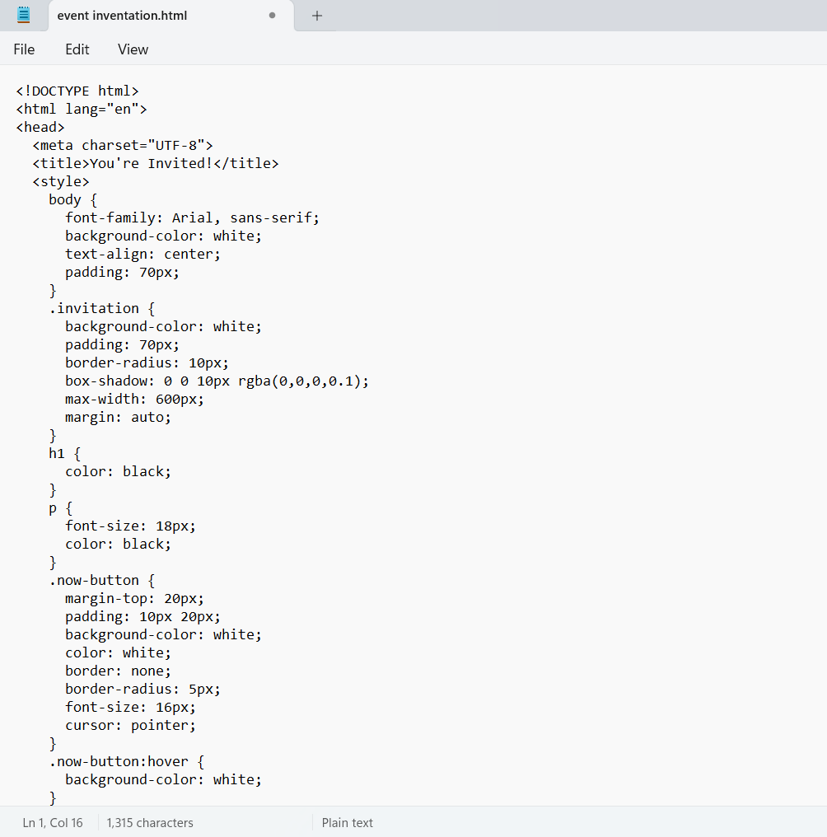
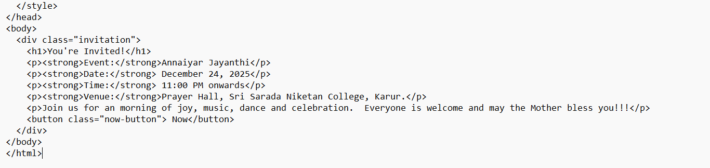

Output:
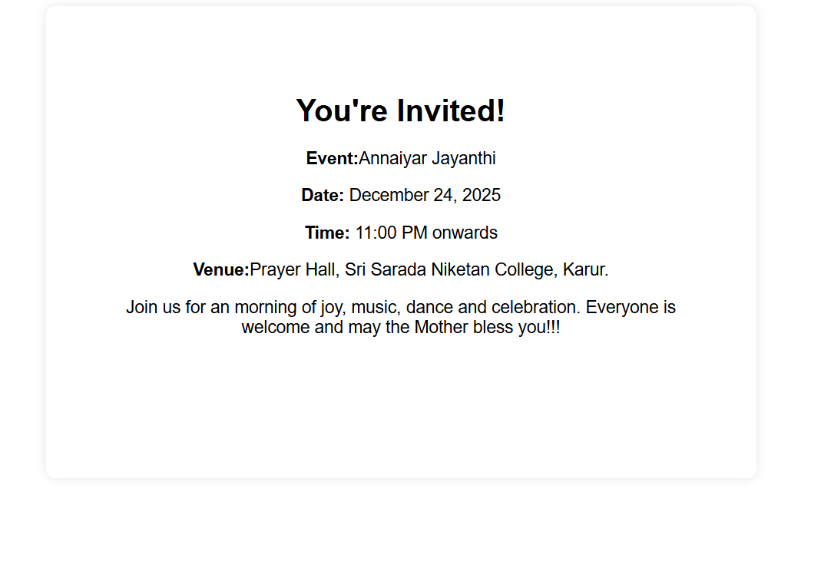
Conclusion:
The Event Invitation Project successfully demonstrates the importance of clear communication, thoughtful design, and proper organization in creating an effective invitation. Overall, the project highlights how a well-crafted event invitation can set the tone for an event, attract attendees, and provide essential information in a professional and engaging way. The knowledge and techniques gained through this project can be applied to future communication materials and similar design tasks.

